**CONTROLLING SERVO MOTOR**

1. **Requirement**

Connect servo motor to Uno board and make it move as you wish.

1. **Circuit**

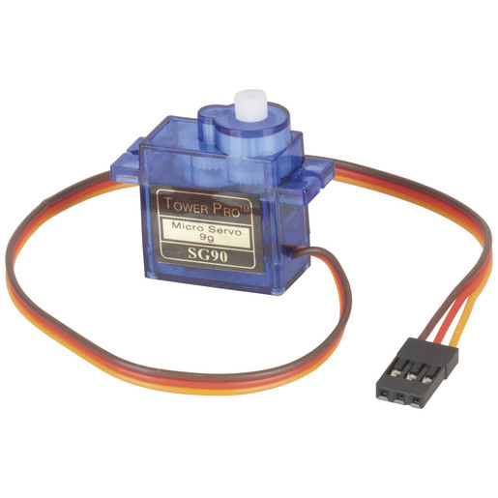

Servo motor SG90 pin layout:

Brown: GND pin

Red : VCC (5V) pin

Yellow: Controlling signal pin

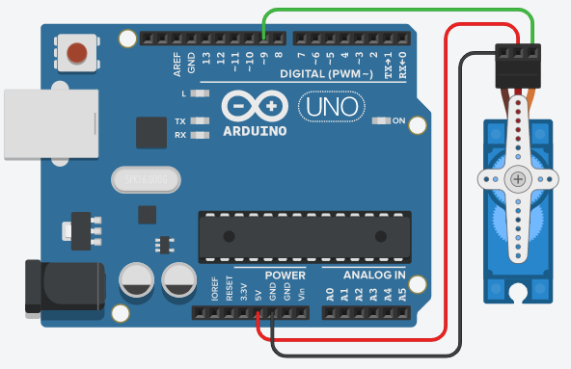

1. **Install library for servo**

Select the newest version and install it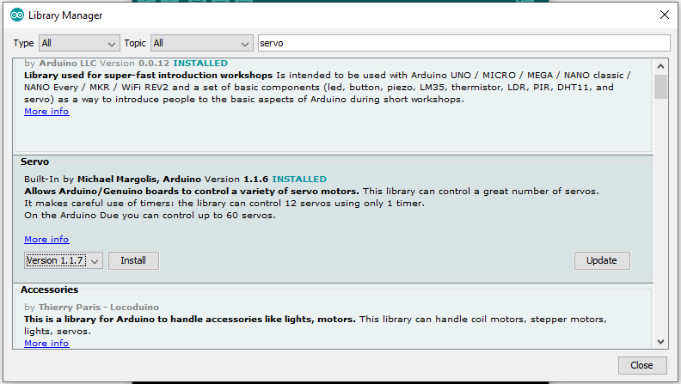

1. **Code the Sketch**

#include <Servo.h>

int pos = 0;

Servo servo_9;

void setup()

{

servo_9.attach(9);

}

void loop()

{

// sweep the servo from 0 to 180 degrees in steps

// of 1 degrees

for (pos = 0; pos <= 180; pos += 1) {

// tell servo to go to position in variable 'pos'

servo_9.write(pos);

// wait 15 ms for servo to reach the position

delay(15); // Wait for 15 millisecond(s)

}

for (pos = 180; pos >= 0; pos -= 1) {

// tell servo to go to position in variable 'pos'

servo_9.write(pos);

// wait 15 ms for servo to reach the position

delay(15); // Wait for 15 millisecond(s)

}

}